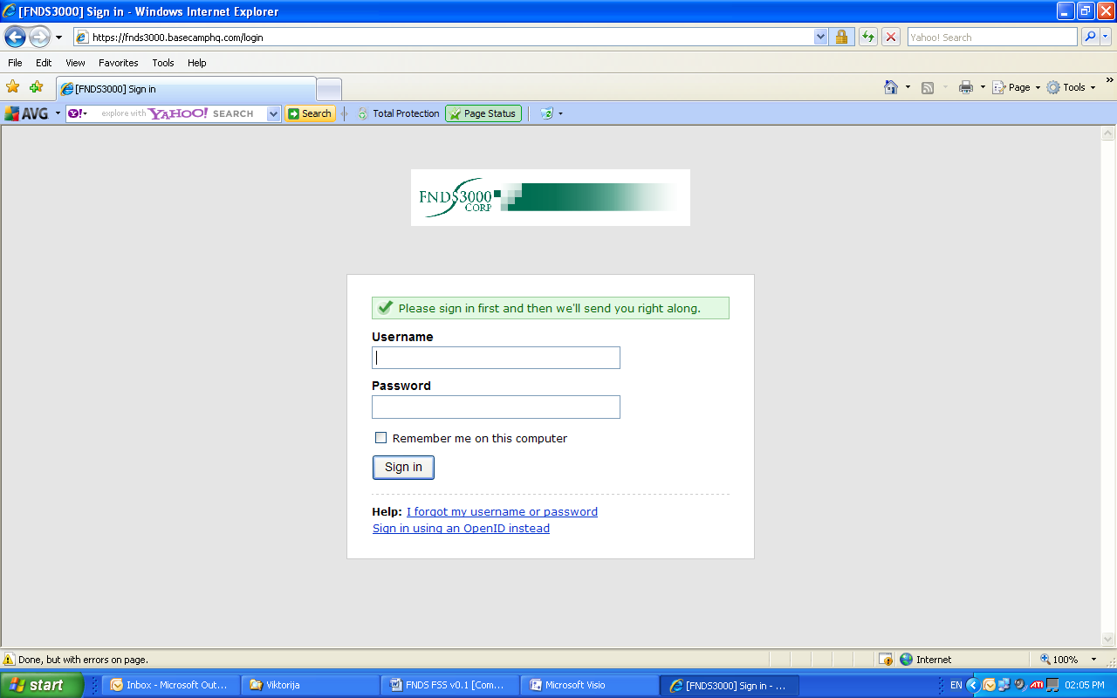

ISO Third Party Integration Specification

**FNDS3000 Platform**

**Department:** FNDS3000 IT

**Created Date:** 29.06.2018

**Last Modified**: 29.06.2018

**Version:** 1.0

© 2018 Confidential

Document Approval Sign-off

|  |  |  |  |  |  |
| --- | --- | --- | --- | --- | --- |
| **Document Approval Sign-off** | | | | | |
| **Name** | **Role** | **Company** | **Conditions of Approval if Any** | **Signature** | **Date** |
|  |  |  |  |  |  |
|  |  |  |  |  |  |
|  |  |  |  |  |  |
|  |  |  |  |  |  |
|  |  |  |  |  |  |

Distribution List

|  |  |
| --- | --- |
| **Distribution List** | |
| **Name** | **Role** |
|  |  |
|  |  |
|  |  |
|  |  |
|  |  |
|  |  |
|  |  |
|  |  |
|  |  |
|  |  |
|  |  |

Document Revision History

|  |  |  |  |
| --- | --- | --- | --- |
| **Revision** | **Pages Changed** | **Change description** | **Date** |
| 1 |  | Initial Draft | 29/06/2018 |
|  |  |  |  |
|  |  |  |  |

Contents

Document Approval Sign-off ii

Distribution List iii

Document Revision History 4

1 INTRODUCTION 6

1.1 Purpose of the Document 6

1.2 Overview 6

1.3 Scope 6

1.4 Assumptions & Concerns 6

1.5 Exclusions 6

2 Standards 7

3 ISo Messages 7

3.1 Message Details 7

3.1.1 Sign On 7

3.1.2 Echo 7

3.1.3 Authorisation 7

3.1.4 Sign Off 7

4 Users Affected 8

5 Reference Documentation 8

6 Acronyms 9

# INTRODUCTION

## Purpose of the Document

The purpose of this document is to specify the ISO 8583 messages that will be exchanged between FNDS3000 and third party systems for purposes of financial messages that need to be sent to third party for approval.

## Overview

The FNDS ISO Gateway is a based upon ISO 8583 running on a WildFly Application Server. It will forward requests from MasterCard to Third party systems for authorisation should that be required.

## Scope

This document will only cover all the ISO messages that a third party system can expect.

It will also cover the PCI related information and how that is handled.

## Assumptions & Concerns

* Understanding of ISO 8583.
* You are reading this document together will the following:
  + Customer Interface Specification.pdf
  + SampleMessages.xlsx

## Exclusions

# Standards

ISO 8583 will be used to establish, maintain connectivity and forward messages for authorisation. The messages are based on the MasterCard ASCII implementation. Details can be found in the Customer Interface Specification.pdf For this connectivity to be established and kept alive, a TCP/IP socket will need to be opened from the FNDS side. The client will need to provide FNDS3000 with the IP and port to connect to. FNDS3000 will be coming from 41.0.12.100

# ISo Messages

## Message Details

### Sign On

To initiate connectivity and 0800 message will be sent and a 0810 message is the expected response. Please see SampleMessages.xlsx & Customer Interface Specification.pdf for what the messages looks like and also the detailed specification.

### Echo

To keep the connection open, an echo message will be sent(0800) and received(0810). Please see SampleMessages.xlsx & Customer Interface Specification.pdf for what the messages looks like and also the detailed specification.

### Authorisation

For authorisation of a message FNDS3000 will send a 0100 and will expected a 0110 as a response. The messages will not include card data. Please have a look at SampleMessages.xlsx & Customer Interface Specification.pdf to see what data to expect.

### Sign Off

To disconnect, a Sign Off will take place. A 0800 message will be sent and a 0810 message is the expected response. Please see SampleMessages.xlsx & Customer Interface Specification.pdf for what the messages looks like and also the detailed specification. This will be used for network outages and maintenance.

# Users Affected

All customers who make use of the web service API in order to integrate to the Acorn Platform.

# Reference Documentation

| **Document Name** | **Version** |
| --- | --- |
|  |  |
|  |  |
|  |  |
|  |  |
|  |  |
|  |  |
|  |  |
|  |  |

# Acronyms

| **Acronyms** | **Description** |
| --- | --- |
| ISO 8583 | International standard for financial transaction card originated interchange messaging |
| PCI | Payment Card Industry |
|  |  |
|  |  |